NADAR SARASWATHI COLLEGE OF ENGINEERING AND TECHNOLOGY

DEPARTMENT OF ELECTRICAL AND ELECTRONICS ENGINEERING

E-FANZINE

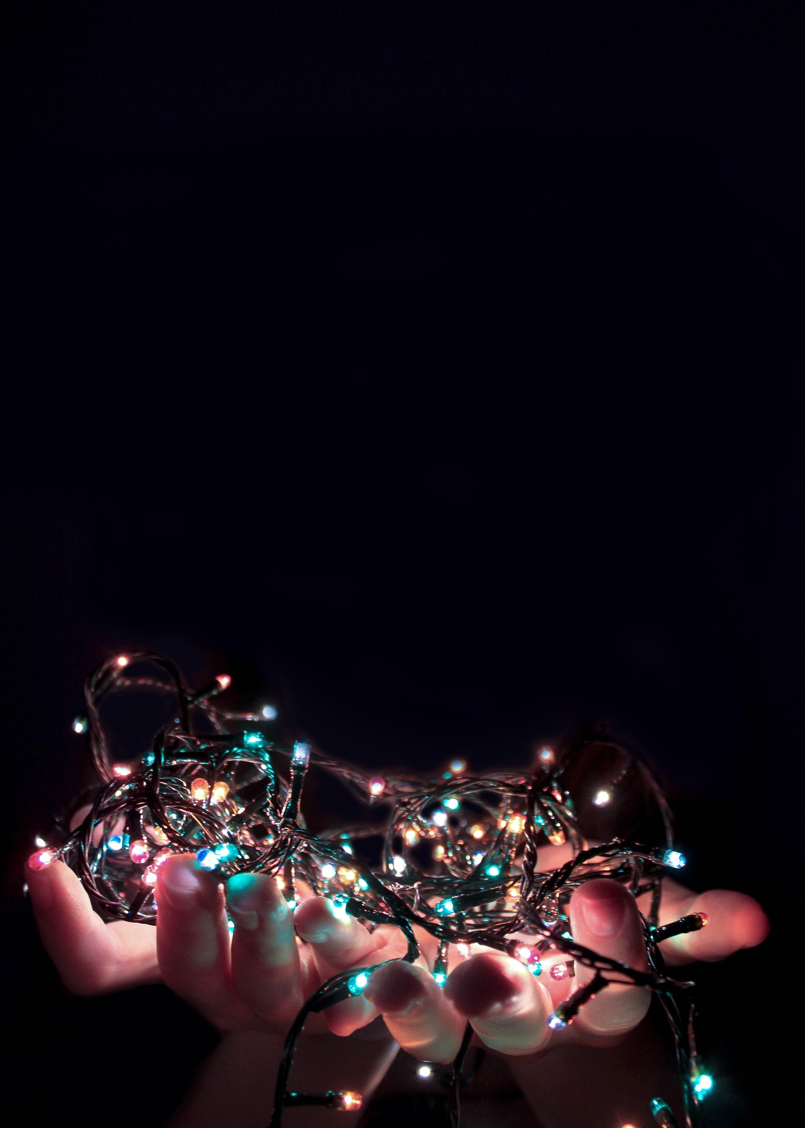
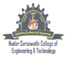
VOL.1 ISSUE:6
MAY 2021

CONTENTS

COLLEGE VISION MISSION
DEPARTMENT VISION MISSION
STAFF ACTIVITY

EDITORIAL BOARD

VOL.NO:1 ISSUE 6 /MAY 2021

VISION OF NSCET
Place for Technology Revolution

MISSION OF NSCET
Promote and undertake all-inclusive developments. (Vision)
Develop high-quality technical education with academic excellence and innovative research with ethics. (TLP)
Create an atmosphere where teacher enjoys facilitation and learners (students) enjoy learning through foster innovation. (PEO & PSO)
Collaborate with industry and academic to meet the changing needs of society. (PO Attainment)

VISION
Emerge as a valuable global resource for power sector and consumer electronics
MISSION
- Establish the cognitive and effective domains of students through appropriate teaching-learning process and industry-institute interactions.
- Execute projects with integrity and ethics keeping pace with the latest trends in power electronics industry.
- Develop energy technology part to handle various sustainability challenges of the society.
- Upgrade the knowledge and skills of faculty through quality improvement programs.

From the HOD desk

Good day, everybody.

Greetings!!! From The department of Electrical and Electronics Engineering of NSCET. The department of EEE is one of the oldest engineering departments which Enlightens any other engineering discipline. Can you Hink of a minute without ELECTRICAL POWER? NO, We can’t. The cross-country power transmission lines, household lights, and motors to name the very few are the best examples illustrating this. We, He electrical engineers have created a great infrastructure in which the world runs on top of it. We will also create the future. WIRELESS POWER TRANSFER, SOLAR POWER, ELECTRICAL
VEHICLES, to name a few. The future is OURs.
We dedicate E-FANZINE, to the students’ fraternity of the EEE department of our institution. Students can actively do a variety of activities which takes them towards becoming an industry leader. All of these activities can be documented in this newsletter. This newsletter is monthly where any student and faculty can contribute to it. I wish all the students and faculty make full use of it and a grand success.

M.Arivalagan HOD/EEE.

VOL.NO:1 ISSUE 6 / APR 2021

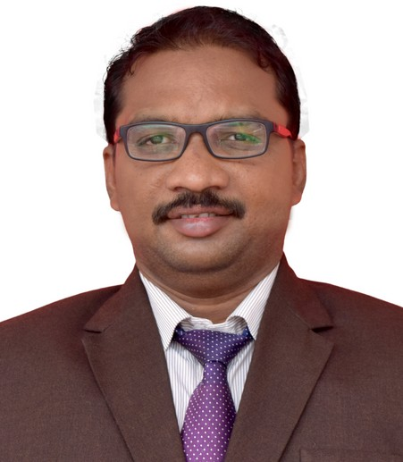
Mr. ARIVALAGAM
HOD/EEE

He has participated in the one day online short-term training program on international conference on Emerging Electrical systems and control (ICEESC 2021), from 06-05-2021 to 07-05-2021 organized by Sethu Institute of Engineering and Technology, Viruthunagar with Institute for Engineering Research and publications.
He has participated in AICTE sponsored the two weeks online short-term Faculty Development Program (FDP) training program on Electrical Paradigm Shift to Cyber Physical systems and Contemporary Research in Electrical and Electronics Engineering from 03-05-21 to 15-05-2021 organized by Saranathan College of Engineering Tiruchirappalli.

He actively Participated in Anna University Sponsored online six days FDTP on Electrical Machines - I organized by K. Ramakrishnan College of Technology, Trichy from 17-05-2021 to 22-05-2021.

He also participated He Webinar on” Agile Methodology” organized by Department of Electrical and Electronics Engineering, Nadar Saraswathi College of Engineering and Technology with Industry Institute Partnership Cell (IIPC) on 25th May 2021.

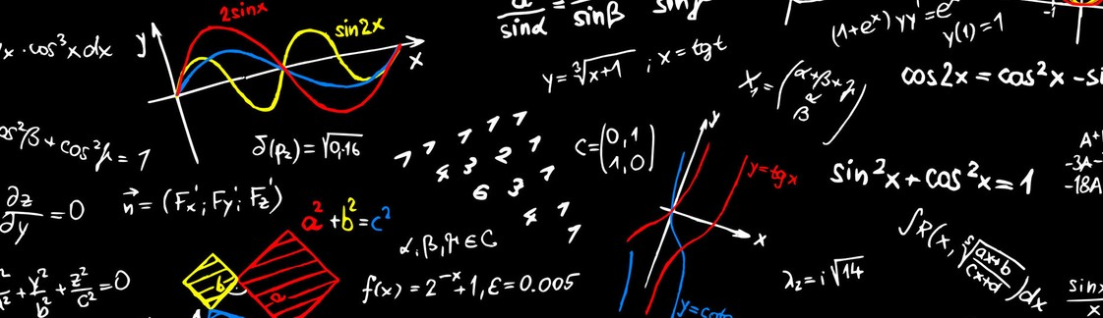

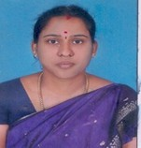
MS. K. MALAR
AP/EEE

She has participated in the one day online short-term training program on international conference on Emerging Electrical systems and control (ICEESC 2021), from 06-05-2021 to 07-05-2021 organized by Sethu Institute of Engineering and Technology, Viruthunagar with Institute for Engineering Research and publications.
She has participated in AICTE sponsored the two weeks online short-term Faculty Development Program (FDP) training program on Electrical Paradigm Shift to Cyber Physical systems and Contemporary Research in Electrical and Electronics Engineering from 03-05-21 to 15-05-2021 organized by Saranathan College of Engineering Tiruchirappalli.

She actively Participated in Anna University Sponsored online six days FDTP on Electrical Machines - I organized by K. Ramakrishnan College of Technology, Trichy from 17-05-2021 to 22-05-2021.
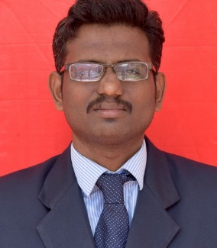

Mr. K. GANESH
AP/EEE

He has participated in the one day online short-term training program on international conference on Emerging Electrical systems and control (ICEESC 2021), from 06-05-2021 to 07-05-2021 organized by Sethu Institute of Engineering and Technology, Viruthunagar with Institute for Engineering Research and publications.
He has participated in AICTE sponsored the two weeks online short-term Faculty Development Program (FDP) training program on Electrical Paradigm Shift to Cyber Physical systems and Contemporary Research in Electrical and Electronics Engineering from 03-05-21 to 15-05-2021 organized by Saranathan College of Engineering Tiruchirappalli.

He actively Participated in Anna University Sponsored online six days FDTP on Electrical Machines - I organized by K. Ramakrishnan College of Technology, Trichy from 17-05-2021 to 22-05-2021.

He also participated He Webinar on” Agile Methodology” organized by Department of Electrical and Electronics Engineering, Nadar Saraswathi College of Engineering and Technology with Industry Institute Partnership Cell (IIPC) on 25th May 2021.

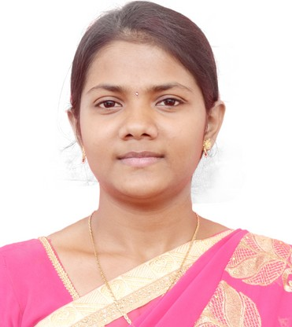

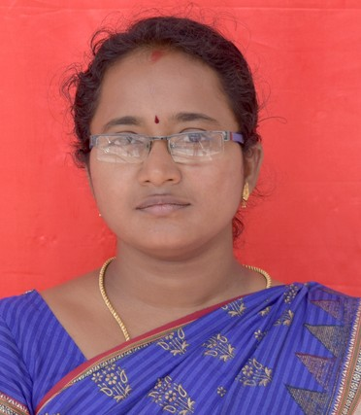

MS. B.SHANHINI

AP/EEE

WEBINAR:
She actively Participated in the webinar on Ideation – How to develop an idea? organized by Department of Electrical and Electronics Engineering, Nadar Saraswathi College of Engineering and Technology, Theni with Intuition’s Innovation Council on 05th May.

She actively Participated in the webinar on “Successful Start-up Founders” organized by Department of Civil Engineering, Nadar Saraswathi College of Engineering and Technology, Theni with Intuition’s Innovation Council on 06th May.

She actively Participated in the webinar on “Cooling system development and significance in Thermal applications” organized by Department of Mechanical Engineering, Nadar Saraswathi College of Engineering and Technology, Theni with Intuition’s Innovation Council on 15th May
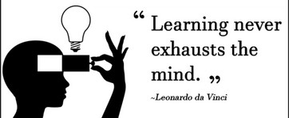

MS. M.DIVYABHARATHI

AP/EEE

WEBINAR:
She actively Participated in the webinar on Ideation – How to develop an idea? organized by Department of Electrical and Electronics Engineering, Nadar Saraswathi College of Engineering and Technology, Theni with Intuition’s Innovation Council on 05th May.

She actively Participated in the webinar on “Successful Start-up Founders” organized by Department of Civil Engineering, Nadar Saraswathi College of Engineering and Technology, Theni with Intuition’s Innovation Council on 06th May.

She actively Participated in the webinar on “Cooling system development and significance in Thermal applications” organized by Department of Mechanical Engineering, Nadar Saraswathi College of Engineering and Technology, Theni with Intuition’s Innovation Council on 15th May

She also participated He Webinar on” Agile Methodology” organized by Department of Electrical and Electronics Engineering, Nadar Saraswathi College of Engineering and Technology with Industry Institute Partnership Cell (IIPC) on 25th May 2021.

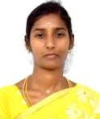

MRS. R.CHITRA

AP/EEE

WEBINAR:
She actively Participated in the webinar on Ideation – How to develop an idea? organized by Department of Electrical and Electronics Engineering, Nadar Saraswathi College of Engineering and Technology, Theni with Intuition’s Innovation Council on 05th May.

She actively Participated in the webinar on “Successful Start-up Founders” organized by Department of Civil Engineering, Nadar Saraswathi College of Engineering and Technology, Theni with Intuition’s Innovation Council on 06th May.

She actively Participated in the webinar on “Cooling system development and significance in Thermal applications” organized by Department of Mechanical Engineering, Nadar Saraswathi College of Engineering and Technology, Theni with Intuition’s Innovation Council on 15th May

She also participated He Webinar on” Agile Methodology” organized by Department of Electrical and Electronics Engineering, Nadar Saraswathi College of Engineering and Technology with Industry Institute Partnership Cell (IIPC) on 25th May 2021.

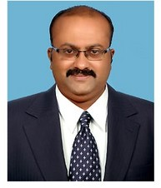

Dr. M. PANDIMAHARAJAN

ASSOSIATE PROFESSOR/EEE

WEBINAR:
He actively Participated in the webinar on “Successful Start-up Founders” organized by Department of Civil Engineering, Nadar Saraswathi College of Engineering and Technology, Theni with Intuition’s Innovation Council on 06th May.

He actively Participated in the webinar on “Golden steps to become a successful research schooler-Innovative problem selecting, intensive data analysis impressive paper writing” organized by Department of Electrical and Electronics Engineering, Nadar Saraswathi College of Engineering and Technology, Theni with Research development cell on 15th May
.

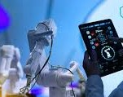
He also participated He Webinar on” Agile Methodology” organized by Department of Electrical and Electronics Engineering, Nadar Saraswathi College of Engineering and Technology with Industry Institute Partnership Cell (IIPC) on 25th May 2021.

Mr. N. RATHINAVEL SUBRAMANIAN

AP/EEE

He has participated in the one day online short-term training program on international conference on Emerging Electrical systems and control (ICEESC 2021), from 06-05-2021 to 07-05-2021 organized by Sethu Institute of Engineering and Technology, Viruthunagar with Institute for Engineering Research and publications.
He has participated in AICTE sponsored the two weeks online short-term Faculty Development Program (FDP) training program on Electrical Paradigm Shift to Cyber Physical systems and Contemporary Research in Electrical and Electronics Engineering from 03-05-21 to 15-05-2021 organized by Saranathan College of Engineering Tiruchirappalli.

He actively Participated in Anna University Sponsored online six days FDTP on Electrical Machines - I organized by K. Ramakrishnan College of Technology, Trichy from 17-05-2021 to 22-05-2021.

He also participated He Webinar on” Agile Methodology” organized by Department of Electrical and Electronics Engineering, Nadar Saraswathi College of Engineering and Technology with Industry Institute Partnership Cell (IIPC) on 25th May 2021.

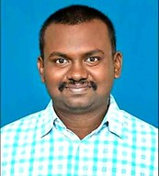

Mr. S. RAHUL SOMNAATH

AP/EEE

He has participated in the one day online short-term training program on international conference on Emerging Electrical systems and control (ICEESC 2021), from 06-05-2021 to 07-05-2021 organized by Sethu Institute of Engineering and Technology, Viruthunagar with Institute for Engineering Research and publications.
He has participated in AICTE sponsored the two weeks online short-term Faculty Development Program (FDP) training program on Electrical Paradigm Shift to Cyber Physical systems and Contemporary Research in Electrical and Electronics Engineering from 03-05-21 to 15-05-2021 organized by Saranathan College of Engineering Tiruchirappalli.

He actively Participated in Anna University Sponsored online six days FDTP on Electrical Machines - I organized by K. Ramakrishnan College of Technology, Trichy from 17-05-2021 to 22-05-2021.

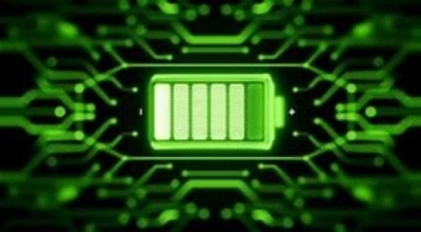

EDITORIAL BOARD

Editor in Chief
Mr. M. Arivalagan HOD/EEE

Editor
Mr. S. Rahul Somnath AP/EEE

Design team
Ms. M. DivyaBharathi AP/EEE
Student members
- Aisswarya Laksmi.M
- Abinayadevi
- Nisha. V
- Senthamilan.S
- Shanmuga Pandian.M
- Sutharsan.T
- Sundharamagalingam.M

VOL.NO:1 ISSUE 6 / MAY 2021

